1. For the following patterns, count the dots, and fill in the table

|  |  |  |  |  |  |
| --- | --- | --- | --- | --- | --- |
| Pattern number | 1 | 2 | 3 | 4 | 5 |
| Dots | 1 | 3 |  |  |  |

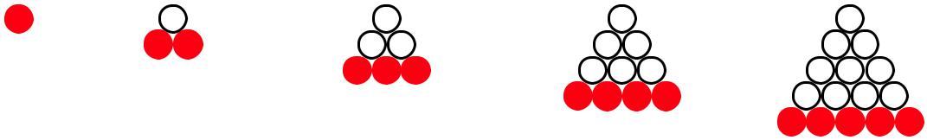

1. 2 3 4 5
   1. How many are being added each time.
   2. find the term formula
   3. How many are in term 10
2. For the following patterns, count the dots, and fill in the table

|  |  |  |  |  |  |
| --- | --- | --- | --- | --- | --- |
| Pattern number | 1 | 2 | 3 | 4 | 5 |
| Dots | 1 | 4 |  |  |  |

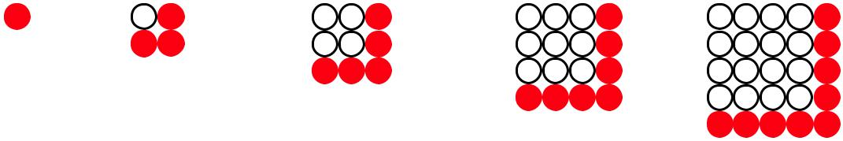

1 2 3 4 5

1. How many are being added each time.
   1. Find the term formula
   2. How many are in term 10
2. For the following patterns, count the dots, and fill in the table

|  |  |  |  |  |  |
| --- | --- | --- | --- | --- | --- |
| Pattern number | 1 | 2 | 3 | 4 | 5 |
| Dots | 1 | 6 |  |  |  |

Term 1 2 3 4 5

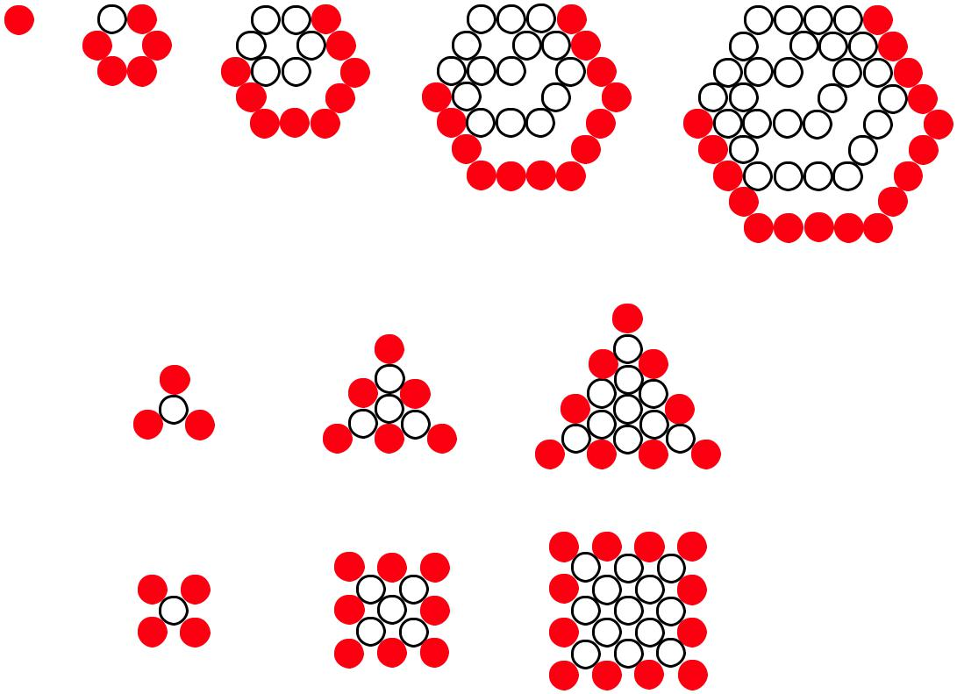

* 1. How many are being added each time.
  2. find the term formula
  3. How many are in term 10

1. For the following patterns, count the dots, and fill in the table

|  |  |  |  |  |  |
| --- | --- | --- | --- | --- | --- |
| Pattern number | 1 | 2 | 3 | 4 | 5 |
| Dots | 4 | 10 |  |  |  |

Term 1 2 3

* 1. Draw the next 2 patterns
  2. How many are being added each time.
  3. find the term formula
  4. How many are in term 10

1. For the following patterns, count the dots, and fill in the table

|  |  |  |  |  |  |
| --- | --- | --- | --- | --- | --- |
| Pattern number | 1 | 2 | 3 | 4 | 5 |
| Dots | 5 | 13 |  |  |  |



Term 1 2 3

* 1. Draw the next 2 patterns
  2. How many are being added each time.
  3. find the term formula
  4. How many are in term 10

1. For the following patterns, count the dots, and fill in the table

|  |  |  |  |  |  |
| --- | --- | --- | --- | --- | --- |
| Pattern number | 1 | 2 | 3 | 4 | 5 |
| Dots | 1 | 7 |  |  |  |

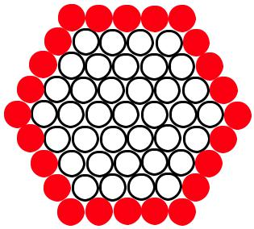









1 2 3 4 5

* 1. How many are being added each time.
  2. find the term formula
  3. How many are in term 10